RBD Project

“Real Estate Rental Agency”

**Table of Contents**

1st Phase 2

Business Requirements 2

ERD Diagram 2

Functional Requirements 3

# 1st Phase

## Business Requirements

Our rental agency requires a database. We need to store data about two types of customers – tenants and owners. Information we have to store is: first name, last name, date of birth, date of registration, languages they speak, phone number etc.  
  
For the owners specifically we want to know how much we pay them each year, when the contract was signed and when it expires or expired.  
  
On the tenant's side we also must know contract dates and how much they pay us each month, their current balance, its history and how many penaltiy points they got.  
  
Another requirement is that we want to know all the information about each real estate, such as type of it (house, flat), address, rental price, current status. Also, in case of shared flats we should know similar information about each room. We have to store history of tenants who were renting specific real estate.  
Also, we want to be able to access information about our employes, when they started working, how much do they make. Some employees are agents and they must be linked to tenants and owners assigned to them by contract. And we should not forget about other staff members, such as janitors, plumbers, electricians.

## ERD Diagram

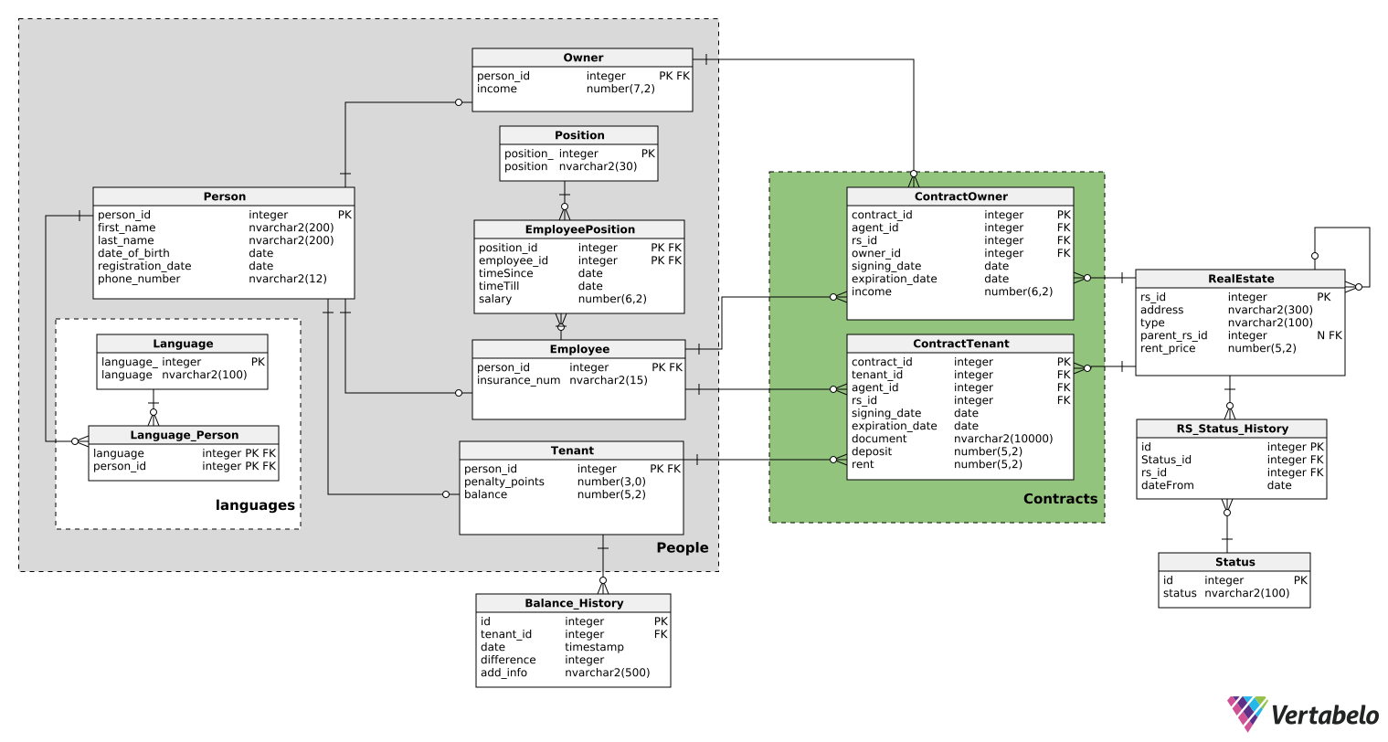

## Functional Requirements

We should be able to execute queries to achieve the following:

1. Retrieve all tenants with a negative balance.
2. Retrieve all contract documents signed after a specific day.
3. Retrieve all real estates with a rent price lower than a specified amount.
4. Determine the number of tenants living in a shared flat.
5. Get all the contracts which were signed by specific agent.
6. Harvest all the phone numbers of tenants whose penalty points exceed some number.
7. Read all the tenants who lived in a specific real estate during some period of time.
8. Search for real estate with specific amount of rooms and specific status.
9. Retrieve details of all employees in agent positions along with their phone numbers, provided their salary exceeds a specific figure.